**Question Set 1**

a. A parent-child relationship

b. Composition

c.

|  |
| --- |
| Species |
| * speciesName:String |
| * Species(s:String, g:String) * setSpeciesName(String s): void * getSpeciesName(): String * toString(): String * equals(s: Species): boolean |

d.

* Code can be reused as Species inherits methods from Genus
* The code is more structured and easier to read

e.

* It doesn’t cause an error because it overrides the toString() method in the Species class
* Overriding

**Question Set 2**

a. Encapsulation in Java is an act of wrapping the data and methods operating on that data into a single unit, hiding it from other classes and only being allowed access through its current class.

b.

* Protection from unwanted access by clients
* Simplifies maintenance

c. setName()

d. cageNumber

e.

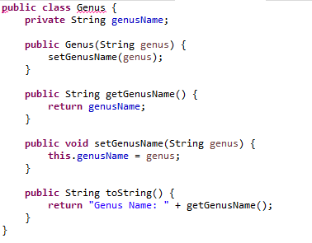

f.

* Advantage: Methods in the Species class are inherited to the Specimen class allowing the methods to be reused
* Disadvantage: Some methods and fields of the specimen would be dependent on the parent class, and it is also difficult to make customize the fields and methods.

**Question Set 3**

a. Adding an instance variable inside Specimen class called marking, adding another parameter for the marking inside the constructor of Specimen class, and adding a getter and setter method for the marking.

b. s